Sandwell Vulnerable Adults Risk Management (VARM) Toolkit
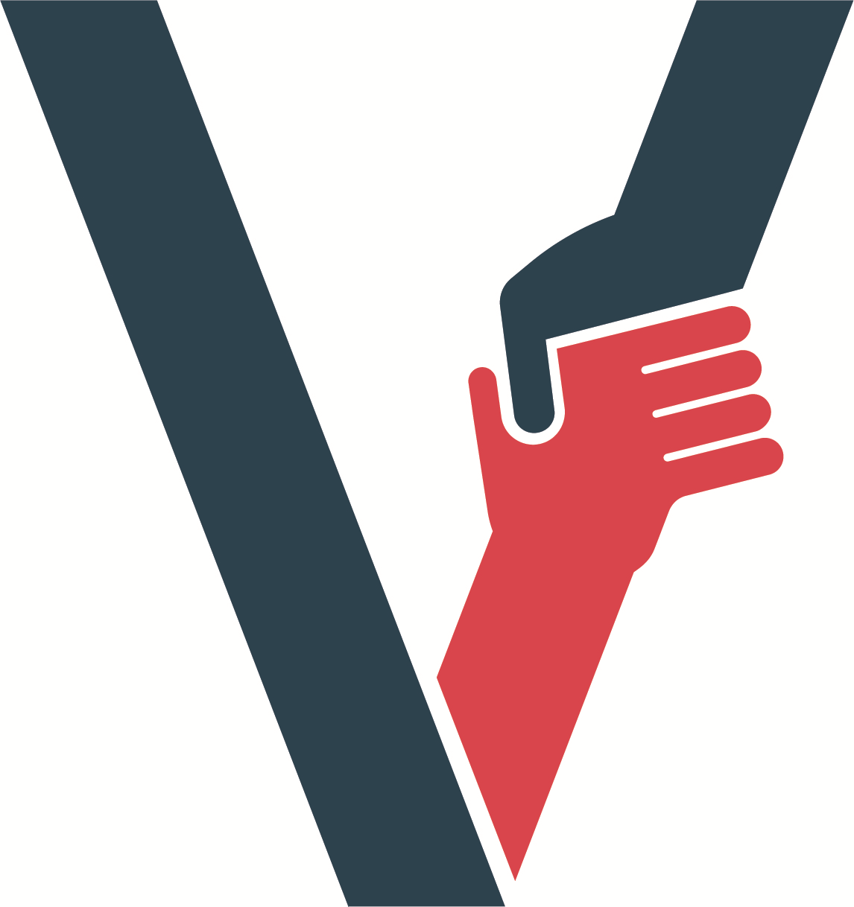

Welcome to the Sandwell Safeguarding Adults Board Vulnerable Adults Risk Management/Meeting (VARM) toolkit. The purpose of this toolkit is to support and inform the work of
- practitioners in a range of settings, develop and build on good practice when considering and/or understanding the role of the VARM process and VARM meetings and safeguarding!
- support and inform the work of Partners and VARM Meeting Chairs in understanding the process, delivering and chairing successful VARM meetings
- Enabling individuals about whom there may be concerns to better understand the process and professionals from a range of agencies to think about how to better involve individuals in their meetings
- This toolkit will have seven sections that will contain material that is relevant and helpful for both Safeguarding Leads, Practitioners, VARM Meeting Chairs, VARM Champions, Service Users, Other resources and Key Messages
This toolkit is new and still in development, so we would welcome any feedback and topics for inclusion, please send to Deb Ward at Deb_ward@sandwell.gov.uk
Safeguarding Leads

VARM framework

Practice Guidance

Practitioners

VARM Meeting Chairs

VARM Champions

Service Users

West Midlands Fire Safety Resources
Fire Safety advice for professionals and carers. Please share with carers.
https://www.wmfs.net/safety/safety-advice-for-professionals-and-carers/
https://walsallsp.walsall.gov.uk/Professionals-Volunteers/Learning-and-Development/Webinars-Videos-and-Learning-Events#105662243-regional-webinar-identification-and-support-for-adults-that-are-at-risk-of-harm-due-to-fire

Other resources you may find helpful

- The Sandwell Multi Agency Adult Safeguarding Procedures
https://www.sandwell.gov.uk/info/200216/adults_and_older_people/2216/
- Strategic framework for an effective Multi-Agency Response to exploitation in the West-Midlands Metropolitan region
- https://www.safeguardingwarwickshire.co.uk/safeguarding-adults/i-work-with-adults/west-midlands-regional-safeguarding-information-hub/west-midlands-exploitation-toolkit
- Channel Panel Guidance
https://www.gov.uk/government/publications/channel-and-prevent-multi-agency-panel-pmap-guidance
- Modern Slavery and Trafficking Pathway
www.sandwell.gov.uk/download/downloads/id/28968/sandwell_moder…

Hi, please see these new additions to the toolkit under the section ‘other resources’.
The first link is to a video demonstrating great working together in Sandwell to safeguard a gentleman whose household had been cuckooed. Please watch the film and learn more.
The second link takes you to drug and alcohol screening tools for adults which you will see as a tile one the Decca website. Please use these tools.
- Cuckooing video: https://vimeo.com/tinkertaylor/review/779642239/10697ea83f
- Drug and alcohol Screening tools (Adults) https://www.ourguideto.co.uk/

- Multiple Exclusion Homelessness A Safeguarding Toolkit for Practitioners

Key Messages

