****

**Resources, Activities and Support available during COVID-19 isolation**

**Sandwell April 2020**

**For more information please visit:**

[**https://www.scvo.info/managing-life-on-the-home-front/**](https://www.scvo.info/managing-life-on-the-home-front/?fbclid=IwAR1DWa3eMXrVykkTtN2-tFxeXHbRx9YcntSSKrFFpuv-mSVR8-QLFMcP6Wk)

[**https://www.nhs.uk/conditions/coronavirus-covid-19/**](https://www.nhs.uk/conditions/coronavirus-covid-19/)

[**https://www.gov.uk/coronavirus**](https://www.gov.uk/coronavirus)

[**https://www.sandwell.gov.uk/coronavirus**](https://www.sandwell.gov.uk/coronavirus)

**Sandwell Networkers Group on Facebook**

**Sandwell Safeguarding Adults Board -** [**https://www.sandwellsab.org.uk/**](https://www.sandwellsab.org.uk/)

*This booklet has been compiled in response to COVID-19 isolation and content is primarily from Sandwell Community and Voluntary Organisations,*

*Sandwell Metropolitan Borough Council and Sandwell Safeguarding Adults Board.*

**For more information please visit:**

[**https://www.scvo.info/managing-life-on-the-home-front/**](https://www.scvo.info/managing-life-on-the-home-front/?fbclid=IwAR1DWa3eMXrVykkTtN2-tFxeXHbRx9YcntSSKrFFpuv-mSVR8-QLFMcP6Wk)

[**https://www.nhs.uk/conditions/coronavirus-covid-19/**](https://www.nhs.uk/conditions/coronavirus-covid-19/)

[**https://www.gov.uk/coronavirus**](https://www.gov.uk/coronavirus)

[**https://www.sandwell.gov.uk/coronavirus**](https://www.sandwell.gov.uk/coronavirus)

**Sandwell Networkers Group on Facebook**

**Sandwell Safeguarding Adults Board -** [**https://www.sandwellsab.org.uk/**](https://www.sandwellsab.org.uk/)

*This booklet has been compiled in response to COVID-19 isolation and content is primarily from Sandwell Community and Voluntary Organisations,*

*Sandwell Metropolitan Borough Council and Sandwell Safeguarding Adults Board.*

April 2020

**Managing life on the home front** –

[https://www.scvo.info/managing-life-on-the-home-front/](https://www.scvo.info/managing-life-on-the-home-front/?fbclid=IwAR1DWa3eMXrVykkTtN2-tFxeXHbRx9YcntSSKrFFpuv-mSVR8-QLFMcP6Wk" \t "_blank)

*If you now find yourself being ‘confined’ to home as a result of the current Coronavirus pandemic it brings a whole new set of lifestyle challenges. Therefore, it’s important to look after your own health and wellbeing and that of others around you (including mental health).*

**Check out our web-page with a host of different activities and information to help you out whilst self-isolating.**



**We’ve gathered resources to help you in these categories:**

**Physical Health**

**Mind Charity** are sharing exercise tips @MindCharity

**Healthy Sandwell** <https://tinyurl.com/t8nocwu> exercise videos.

**Joe Wicks Body Coach** daily exercise – <https://tinyurl.com/ycmqjuh5>

**Davina McCall -** <https://ownyourgoalsdavina.com/>

Access celebrities workouts on Instagram <https://tinyurl.com/wxv74qq>

**Joanna Marcinekova**  <https://tinyurl.com/stxpvgt>

**Katy Taylor Fitness** Body Blast [www.musclesandcurves.co.uk/](http://www.musclesandcurves.co.uk/)

**Jo Howarth** mindset tips - [www.facebook.com/TheHappinessClubLtd/](http://www.facebook.com/TheHappinessClubLtd/)

**Activities for Children and Young People**

**Children’s boxing** <https://www.youtube.com/watch?v=TrJ2nV-6woo>

**Toni’s Tots Drama Facebook** craft ideas <https://tinyurl.com/urfl7fb>

**Yoga for tots** <https://tinyurl.com/uc27pku>

**Amazon Audible** free audiobooks for home-schooling <https://stories.audible.com/start-listen>

**David Walliams** audio books free – [bit.ly/AudioElevenses](http://bit.ly/AudioElevenses)

**The Rainbow Generator** generates ideas [www.whatshallwedo.co.uk](http://www.whatshallwedo.co.uk/).

**Relaxed Kids** mindful moments [www.relaxkids.com/calminthechaos](http://www.relaxkids.com/calminthechaos)

**Education**

**Twinkl** lesson plans and resources [www.twinkl.co.uk/home-learning-hub](https://www.twinkl.co.uk/home-learning-hub)

**Educational resources** <https://tinyurl.com/tmrawcq>

**Carol Vorderman The Maths Factor** -[www.themathsfactor.com/](https://www.themathsfactor.com/)

**BBC Bitesize** online educational resources [www.bbc.co.uk/bitesize](http://www.bbc.co.uk/bitesize)

**Plazzom** Year 1 Home Learning Pack <https://tinyurl.com/qr328fd>

**Minecraft** educational worlds – <https://tinyurl.com/r9s9vqs>

**British Science Assoc -** group activity packs <https://t.co/Qm2vpWe6CT>

**National Literacy Trust**  <https://literacytrust.org.uk/family-zone/>

**Learn a Language**

**Babble** <https://www.babbel.com/>

**British Sign Language** online course, [www.british-sign.co.uk](http://www.british-sign.co.uk/)

**Fun, Culture and Recreation**

**Sandwell Libraries -** twitter @sandwelllibs activity sheets for children.

**Sandwell Museums** quizzes and colouring sheets @SandwellMuseums

**Go Play Sandwell** forest school activities <https://t.co/fPHPl0Jlow>

**Wolves** colouring <https://www.wolves.co.uk/media/12447/wwfc-art.pdf>

**ELEVATE Brain Trainer** 1 month free  <https://www.elevateapp.com/>

**Girl Guiding** adventures from home [www.girlguiding.org.uk](http://www.girlguiding.org.uk/)

**Filmed on Stage** Free musicals & plays <https://tinyurl.com/rqzaedz>

**The National Theatre** <https://tinyurl.com/qnhhcla>

**Chester Zoo** are offering a live virtual zoo day at @chesterzoo

More Creativity - [**www.creativeblackcountry.co.uk/covid19resources**](http://www.creativeblackcountry.co.uk/covid19resources)

**La di Da**  – Upcycling [www.facebook.com/pg/LadidaAndover/about](http://www.facebook.com/pg/LadidaAndover/about)

**Rhiannon** Bake Flat breads [www.facebook.com/TheEpsomBakehouse/](http://www.facebook.com/TheEpsomBakehouse/)

**For more information check out the SCVO website!!**

***Other things to do during isolation***

**Exercise**

**Adaptive Yoga with WheelPower**

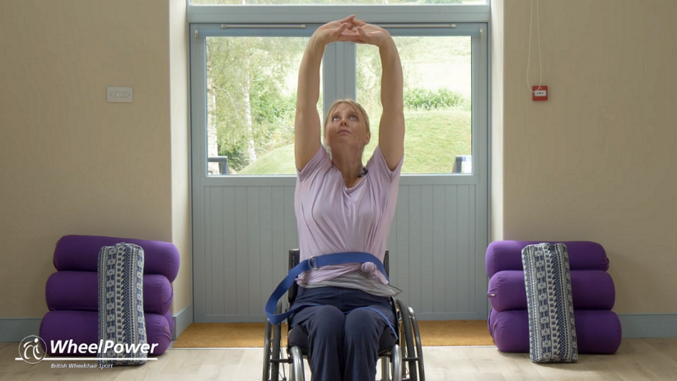

<https://www.wheelpower.org.uk/resources/adaptiveyoga>

[](https://dancesyndrome.co.uk/open-letter-from-dancesyndrome-md-dawn-vickers/)h 18, 2020 

**DanceSyndrome - Free Online Dance Sessions**

[**https://dancesyndrome.co.uk/online-dance-sessions/**](https://dancesyndrome.co.uk/online-dance-sessions/)

**Exercise for limited motability** <https://www.youtube.com/watch?v=A2wp8Ipxn9s>

**Need ideas for staying active at home?**

Here's a great guide: [bit.ly/2vRuo9V](https://l.facebook.com/l.php?u=https%3A%2F%2Fbit.ly%2F2vRuo9V%3Ffbclid%3DIwAR29m9SNwGezKuVLKCb1YVHhbKMV9iJiq8RWfV140X20yHRhv-S0OfgxBXo&h=AT1PPKysmVOArj_3m1zRSjo1VD7B9exyj5s6nzTU64k7oLrSqMzukqmaEUgS-3esPjWefU7oszNTsBIZhf4d4zrj_2CRcL5oREdCgzLqpLOsaDHb8J7G7mD1YH0UHmX4oK50PIR2eFrSAKmdQ930QsGKMZKhZrW3Q8TPOzLTgpnOFkMARJw9MWGFGrJpleqvCStlE22E6U29th5Rz6GfrU0P8XW582gxlyaFG2lFRGU5di4DibooFDx1d16Sqi3wQZ-Y5NMeEh4v14aJPQdkO0926vMe7N9ONNf2KnaWBRyfTew4U97-M4ju_wW6ugQ-SjCR0waflLHbH-3X1D4-M_xHW_QyrN7CUn6TUBwlbZI30l4tmRBu4oxbCMU17A5Ito7aD7tV_nkF2bx0jYiPVsSgFFhiEBLhn93slm5ZDDAtbQxXwvxHdbCV968CnsPRDpqocaqx0fyrsi42g1fWeYG1I4II_stAYHmUJAW1gY0EpGJFKoc8zI6ywpsnyoTwfUw4iZekMBwF2sWj8-akyGWRvqZsrtHMd86HTMJBJA2oRZjDJ3LG5EH4qqueet6rhkt4YQWZtCahrOir5XCKOKYtPvlmbP5BR-ZfKcgv8tR7Io9tkw7woUAZ3ovzZXAsBQ)

[](https://www.facebook.com/sandwellcouncil/photos/a.165528153494848/2778938532153784/?type=3&eid=ARD54GyMaC1J2-97ZLXdBJ_ajelZmgfCtfDFv6xRBUKB828Ah36qIBiuYSTVm3NO12_s2h9sQCm5LSHT&__xts__%5b0%5d=68.ARBVy1bCF8zQZRjJdXvdz22DKtJPIjG5ZeKV6n_jyQmKZSXpyvtagUmUkO86tzk3h0lVedPN_y4ytTuImiF_VhP0Sk1fd8ww0ttz38sG06CBzoowOvNZxk4Dz3-DZKi8eeg_0E6tMe6aDtqOwx3MdHBY-6FL2tezlRVTIuoHtYGn8j4pZtnkBH47XgTBEg_j-g3fpH0ZRneJZLkBpQlKlmQWxEV1DPW22yf67q-JZoZVk3KSfxXnvgpBV5sFIYCzpBMABElvcjTlHwWQR3cVXR8jUMbwoipDknRtZ1ynoNPgqAvayvpLR2XE159sKz2SXURzjVPUJqUUwXILAGjFYEFGvA&__tn__=EHH-R)

**Practical Activities**

**Making Worry Dolls**

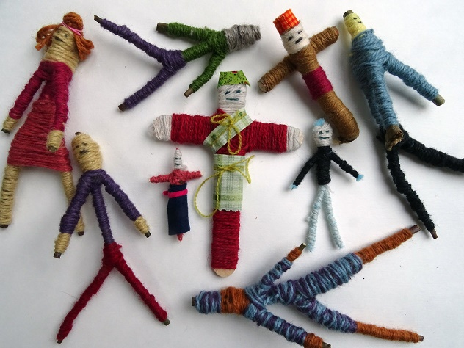

<https://www.accessart.org.uk/worrydolls/>

**Download free adult colouring sheets**

**Gardening** - Window ledge plants/ herbs.

**Baking**

**Sensory Spectacle are doing twice weekly sensory makes at 2pm on Mondays and Thursdays live online.**

<https://www.facebook.com/sensoryspectacle/>

***You Tube have loads of sensory video’s, music.***

**Sensory blankets** – sew pictures in as well as various textured patches

<https://www.youtube.com/watch?v=EzKhq-vyXbs>

**Miscellaneous**

**Empathy Dolls, Music from 40s to 80s**

**Rock painting, Watercolour painting**

**Create memory boxes, Make a new photo album of memories**

**Online**

**Sandwell Libraries** are providing instant access to BorrowBox - a free eBook and eAudiobooks service - for new customers who join online:

[www.sandwell.gov.uk/librariesonline](http://www.sandwell.gov.uk/librariesonline?fbclid=IwAR22hTa0jFcx_bVLHtOgsxElUV-QrWyLC64Nk0UxnqCgJos_uLYzsmKUVc8)

Existing customers: to borrow through BorrowBox <https://capitadiscovery.co.uk/sandwell/home>

**Online Resources**

FREE reference resources can be accessed with your library number.

[Driving Theory Test Pro](http://sandwell.theorytestpro.co.uk/)  
[Go Citizen](http://sandwell.gocitizen.co.uk/)  
[Cobweb Information for Business](http://sandwell.cobwebinfo.com/)

**eMagazines**

[eMagazines website](http://library.magzter.com/) has a wide range of titles to download to your computer, smartphone or tablet.

To register, all you need is your library card number and your email address, then click on [Create a Library user Account](http://library.magzter.com/libraries/register).



**Do your family tree**





<https://fis.sandwell.gov.uk/>

[**Nacoa**](https://www.facebook.com/nacoauk/?__tn__=%2CdkCH-R-R&eid=ARCdemVT-OiIV4uhZUgARb8uzxD96nC5JdOrUtyC6AmCV2wqUJW4ROTXOiMGkjNXY921IFasVgfupBo8&hc_ref=ARS271eoup3PejgqIKikn_M6SvlhodtXwtU2YhDyPIhsIjA-KbML-r4E8Gw85nB53us&fref=nf&hc_location=group) **-**

[The Black Country has some 100 miles of canals, many of which exist today thanks to dedicated campaigners who wouldn’t give up when they fell into disrepair. They formed canal societies, protested, lo](https://soundcloud.com/alarum_theatre/i-dig-canals-podcasts-episode-4-state-of-the-canals-part-2?fbclid=IwAR09W0Qwp0cTVuF6XQN0IsY8jV5Emmck35d_Ywml9Vk-FDjU5KnAh2PaB-c" \t "_blank)

***Dozens of sites offer virtual tours, so you can explore museums, zoos, landmarks and attractions all over the world from your home.***

**Landmarks and Tourist Destinations Virtual Tours**

* [Athens Acropolis, Greece](http://www.yougoculture.com/virtual-tour/athens/myth/acropolis)
* [Buckingham Palace, London](https://www.hotukdeals.com/visit/threaddesc/3429850/16360125)
* [Chichen Itza, Yucatan, Mexico](http://www.destination360.com/north-america/mexico/chichen-itza/virtual-tour)
* [Christ The Redeemer, Rio de Janeiro, Brazil](https://www.youvisit.com/tour/brazil)
* [Cliffs of Moher, Ireland](https://www.cliffsofmoher.ie/virtual-visit-tour/)
* [Colosseum, Rome](https://www.hotukdeals.com/visit/threaddesc/3429850/16359821)
* [Great Wall of China](https://www.hotukdeals.com/visit/threaddesc/3429850/16359781)
* [Hagia Sophia Cathedral, Istanbul, Turkey](http://www.3dmekanlar.com/en/hagia-sophia.html)
* [Machu Picchu, Peru](https://www.youvisit.com/tour/machupicchu?pl=f)
* [National Parks, USA](https://artsandculture.withgoogle.com/en-us/national-parks-service/parks)
* [Northern Lights](https://www.hotukdeals.com/visit/threaddesc/3429850/16360102)
* [Stonehenge](https://www.hotukdeals.com/visit/threaddesc/3429850/16359820)
* [Street Art with Google](https://www.hotukdeals.com/visit/threaddesc/3429850/16359817)
* [Taj Mahal](https://www.hotukdeals.com/visit/threaddesc/3429850/16359787)
* [Tour of Rome, Italy](https://www.hotukdeals.com/visit/threaddesc/3429850/16360124)
* [The Pyramids, Egypt](https://www.hotukdeals.com/visit/threaddesc/3429850/16360126)
* [The White House, Washington DC, USA](https://artsandculture.google.com/partner/the-white-house)

**Museums and Art Galleries Virtual Tours**

* [Anne Franke Museum, Amsterdam, Netherlands](https://www.hotukdeals.com/visit/threaddesc/3429850/16360100)
* [British Museum, London](https://www.hotukdeals.com/visit/threaddesc/3429850/16359793)
* [Guggenheim, Bilbao, Spain](https://www.hotukdeals.com/visit/threaddesc/3429850/16359801)
* [Hermitage Museum, St Petersburg, Russia](https://www.hotukdeals.com/visit/threaddesc/3429850/16359818)
* [History Of Science Museum, Oxford University](https://www.hsm.ox.ac.uk/explore-galleries)
* [J. Paul Getty Museum, Los Angeles, United States](https://www.hotukdeals.com/visit/threaddesc/3429850/16359796)
* [Louvre Museum Paris](https://www.hotukdeals.com/visit/threaddesc/3429850/16359780)
* [MASP, Sao Paolo, Brazil](https://www.hotukdeals.com/visit/threaddesc/3429850/16359800)
* [Met Museum, New York](https://www.hotukdeals.com/visit/threaddesc/3429850/16359799)
* [Musée d’Orsay, Paris](https://www.hotukdeals.com/visit/threaddesc/3429850/16359802)
* [Musei Vaticani, Vatican City](https://www.hotukdeals.com/visit/threaddesc/3429850/16359797)
* [Museum Of London Docklands](https://www.hotukdeals.com/visit/threaddesc/3429850/16359791)
* [Museum of Flight](https://www.hotukdeals.com/visit/threaddesc/3429850/16360099)
* [National Gallery, London](https://www.hotukdeals.com/visit/threaddesc/3429850/16359792)
* [National Gallery Of Arts, Washington DC](https://www.hotukdeals.com/visit/threaddesc/3429850/16359788)
* [Natural History Museum, London](https://www.hotukdeals.com/visit/threaddesc/3429850/16359794)
* [National Museum of Computing on Bletchley Park](https://www.hotukdeals.com/visit/threaddesc/3429850/16359819)
* [National Museum Of US Air Forces](https://www.hotukdeals.com/visit/threaddesc/3429850/16360098)
* [Picasso Museum, Barcelona](https://www.hotukdeals.com/visit/threaddesc/3429850/16359814)
* [Rijksmuseum, Amsterdam, Netherlands](https://www.hotukdeals.com/visit/threaddesc/3429850/16359795)
* [Royal Academy Of Arts, London](https://www.hotukdeals.com/visit/threaddesc/3429850/16359819)
* [Salvatore Dali Museum, Figueres, Spain](https://www.hotukdeals.com/visit/threaddesc/3429850/16359790)
* [Smithsonian, Washington DC](https://www.hotukdeals.com/visit/threaddesc/3429850/16359783)
* [Tate Britain, London](https://www.hotukdeals.com/visit/threaddesc/3429850/16359798)
* [Uffizi Gallery, Florence, Italy](https://www.hotukdeals.com/visit/threaddesc/3429850/16359785)
* [US Holocaust Museum](https://www.hotukdeals.com/visit/threaddesc/3429850/16360101)
* [Van Gogh Museum, Amsterdam, Netherlands](https://www.hotukdeals.com/visit/threaddesc/3429850/16359786)
* [Virginia Living Museum](https://www.hotukdeals.com/visit/threaddesc/3429850/16359815)
* [Yale Centre For British Art](https://www.hotukdeals.com/visit/threaddesc/3429850/16359819)

**Theme Parks and Attractions Virtual Tours**

* [AirPano](https://www.hotukdeals.com/visit/threaddesc/3429850/16359784)
* [Berliner Philharominker](https://www.hotukdeals.com/visit/threaddesc/3429850/16350686)
* [Kennedy Space Centre, NASA](https://www.hotukdeals.com/visit/threaddesc/3429850/16360127)
* [Legoland](https://www.hotukdeals.com/visit/threaddesc/3429850/16359826)
* [Walt Disney Parks](https://www.hotukdeals.com/visit/threaddesc/3429850/16359825)
* [Wellcome Collection](https://www.hotukdeals.com/visit/threaddesc/3429850/16359835)

**Zoos and Aquariums Virtual Tours**

* [African Animals](https://www.hotukdeals.com/visit/threaddesc/3429850/16360105)
* [Atlanta Zoo](https://www.hotukdeals.com/visit/threaddesc/3429850/16359808)
* [Cincinnati Zoo](https://www.hotukdeals.com/visit/threaddesc/3429850/16359810)
* [Dublin Zoo](https://www.hotukdeals.com/visit/threaddesc/3429850/16360103)
* [Edinburgh Zoo](https://www.hotukdeals.com/visit/threaddesc/3429850/16359813)
* [Explore.org Live Cams](https://www.hotukdeals.com/visit/threaddesc/3429850/16360128)
* [Flamingo Land](https://www.hotukdeals.com/visit/threaddesc/3429850/16359911)
* [Florida Aquarium](https://www.hotukdeals.com/visit/threaddesc/3429850/16359816)
* [Hirakawa Zoo, Japan](https://www.hotukdeals.com/visit/threaddesc/3429850/16359807)
* [International Wolf Centre](https://www.hotukdeals.com/visit/threaddesc/3429850/16360106)
* [Kansas City Zoo](https://www.hotukdeals.com/visit/threaddesc/3429850/16360104)
* [Melbourne Zoo](https://www.hotukdeals.com/visit/threaddesc/3429850/16359809)
* [National Aquarium, USA](https://www.hotukdeals.com/visit/threaddesc/3429850/16360129)
* [National Zoo, Washington DC](https://www.hotukdeals.com/visit/threaddesc/3429850/16359783)
* [Osaka Zoo](https://www.hotukdeals.com/visit/threaddesc/3429850/16359812)
* [San Diego, California, Zoo](https://www.hotukdeals.com/visit/threaddesc/3429850/16359811)
* [Yellowstone National Park](https://www.hotukdeals.com/visit/threaddesc/3429850/16359789)

**Lots of activities available on social media – Quizzes, Games etc**

****

**National Support Services**

**Childline**: 0800 1111  
**Samaritans**: **Call 116 123** <https://www.samaritans.org/>

**Domestic Violence Hotline**: 0808 2000 247  
**Age UK:** 0800 169 6565

**Mind**: 0300 123 3393 @MindCharity for tips and ideas. <https://www.mind.org.uk/information-support/coronavirus-and-your-wellbeing/>

<https://www.anxietyuk.org.uk/coronanxiety-support-resources/>

Helpline (03444 775774) Anxiety UK also hold online support groups

#Coronanxiety webinars for carers. <https://nopanic.org.uk/coronavirus/>

**No Panic Helpline 0844 967 4848. (Not a free number – we need to make sure people are aware calling from a mobile can be expensive up to 55p a min).** You can access the crisis message 24hrs daily by calling 01952 680835

**Sandwell Support, Advice and Guidance**

**Sandwell Complex Communication and Autism Team** visual supports   
Contact [jane\_campbell@sandwell.gov.uk](mailto:jane_campbell@sandwell.gov.uk) with what you need

**Sandwell Citizen’s Advice** webchat [www.citizensadvicesandwell.org.uk](http://www.citizensadvicesandwell.org.uk/) or email your questions here<https://citizensadvicesandwell.org.uk/contact-us/>

**Sandwell Advice Line**: 0300 330 9017

**Help to Claim Universal Credit**: 0800 144 8444

**Sandwell Council** useful information [www.sandwell.gov.uk/info/200347/resilient\_residents](http://www.sandwell.gov.uk/info/200347/resilient_residents).

**School Nurses**confidential text Chat Health 07480635486.

**Sandwell West Birmingham Hospital Trust**for sexual health clinics text 07950080764 or call 0121 612 2323

**Guru Nanak Gurdwara Smethwick**community support network for people 65+ will be providing grocery shopping, prescription & food bank services. Call 0121 5582527.

**Black Country Hub** - business support information #COVID19 [https://t.co/LAPADRZCtC](https://bcgrowthhub.com/coronavirus-covid19)

**Connections Sandwell** Information, advice and guidance on 0121 569 2955 and email [Sandwell\_Connections@sandwell.gov.uk](mailto:Sandwell_Connections@sandwell.gov.uk)

**Association of Chairs** - coronavirus resource page <https://t.co/56fbaJnQcb>

**La Leche League:** 0345 1202918 for mum’s struggling to get formula milk.

**iSE Social Enterprise CIC** has launched a #COVID19 Social Enterprise Helpline for any social enterprise across Birmingham and Solihull – call 0121 771 1411

**Challenging Behaviour Support** <https://www.challengingbehaviour.org.uk/cbf-articles/latest-news/guidanceforfamilies.html>

<https://www.challengingbehaviour.org.uk/information/information-sheets-and-dvds/info-sheets-and-dvds.html> (Information sheets for carers)

email:[support@thecbf.org.uk](mailto:support@thecbf.org.uk) : Call F**amily Support** 0300 666 0126

**Carers UK** have guidance for carers

<https://www.carersuk.org/help-and-advice/health/looking-after-your-health/coronavirus-covid-19>

Online carers forums

Postural care Leaflet : https://www.simplestuffworks.com/wp-content/uploads/2016/10/PosturalCareLeaflet.pdf

**Mental and Emotional Wellbeing**

**Sandwell Deaf Community Assoc @**sandwelldearcom Text/facetime on 07885913225.

**Black Country Womens Aid** for women or men needing support call 0121 552 6448 or email [info@blackcountrywomensaid.co.uk](mailto:info@blackcountrywomensaid.co.uk)

**Respect** phone/webchat to manage behaviour [respectphoneline.org.uk](http://respectphoneline.org.uk/) call 0808 8024040.

**Kaleidoscope Plus** – support [counselling@kaleidoscopeplus.org.uk](mailto:counselling@kaleidoscopeplus.org.uk) or call 0121 565 5605.

**Midlands Mencap** - phone support – Weekdays – 8am-8pm Weekends – 10am-4pm Reach Out Service call anyone who is self-isolating, lonely or anxious ring and we’ll stay in touch. Follow social media for content on wellbeing, activities, hobbies and fun. Call 0121 4276404 or Email [families@midlandmencap.org.uk](mailto:families@midlandmencap.org.uk) Twitter @MidlandMencapUK

**Black Country Growth Hub** 0300 770 2245 email [enquiries@bcgrowthhub.com](mailto:enquiries@bcgrowthhub.com) Twitter @bcgrowthhub sharing tips and information on how to stay active.

**Dudley Take Five -** Five Ways to Wellbeing. [www.youtube.com](http://www.youtube.com/)

**Pilates Sarah Perkins** –  [www.facebook.com/nottspilates/](http://www.facebook.com/nottspilates/)

**Meditation Caroline Lions** – <https://youtu.be/WbZ9XtjTXkQ>

**Yoga Jane Grogan** – <https://www.facebook.com/pg/iloveoneself/about/>

[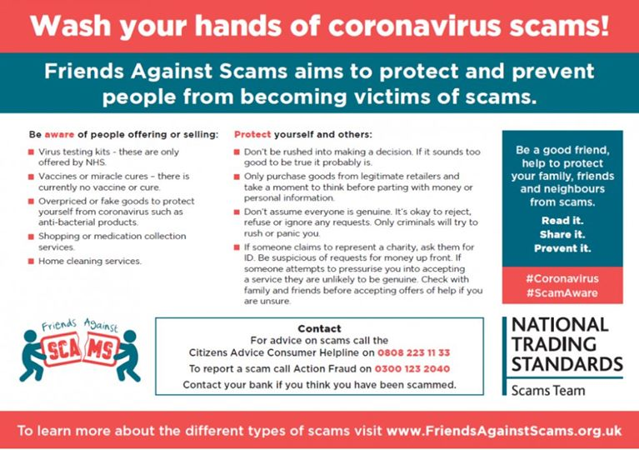](https://www.facebook.com/sandwellcouncil/photos/a.165528153494848/2774498572597780/?type=3&eid=ARBxDSgy62YwocpaC_QG2TbovGvEhlb7SqlqYEK6BQfWnmdNDQBgETO3UkSVgujjM9pw85tyk6I7Wavp&__xts__%5b0%5d=68.ARAsUw7T78GRBYW0pMzQjQvhOHs-cngfpMAK9eBpksxIv_TkGtkKJBnblr97vMHAuA8vMKf3fJi1HMAomX46UBJwcAbxMDcD4ZrqAv4ggFdtCfbQ9isR0v_34EtZqWssouC4-a3W00nE3KVNe-UF1BrYp8FC6lZdBN9CZOfzN2-tBNfc9sLbVzvaqJTTlyE8eSV28qgYSltLUto4TfNMSC--fqc5iZ3lbIYZkW8xbetS1Cl9AF4xo84L6FJ7n-X639lGChvHxpYruRCvndVZfv9FyX4FCYS2hJ6JtF6CH2JG_c6eXGzVge8gkYZdefi-ZyO-ySAte3WxozCW6zhOtoU3NA&__tn__=EHH-R)



