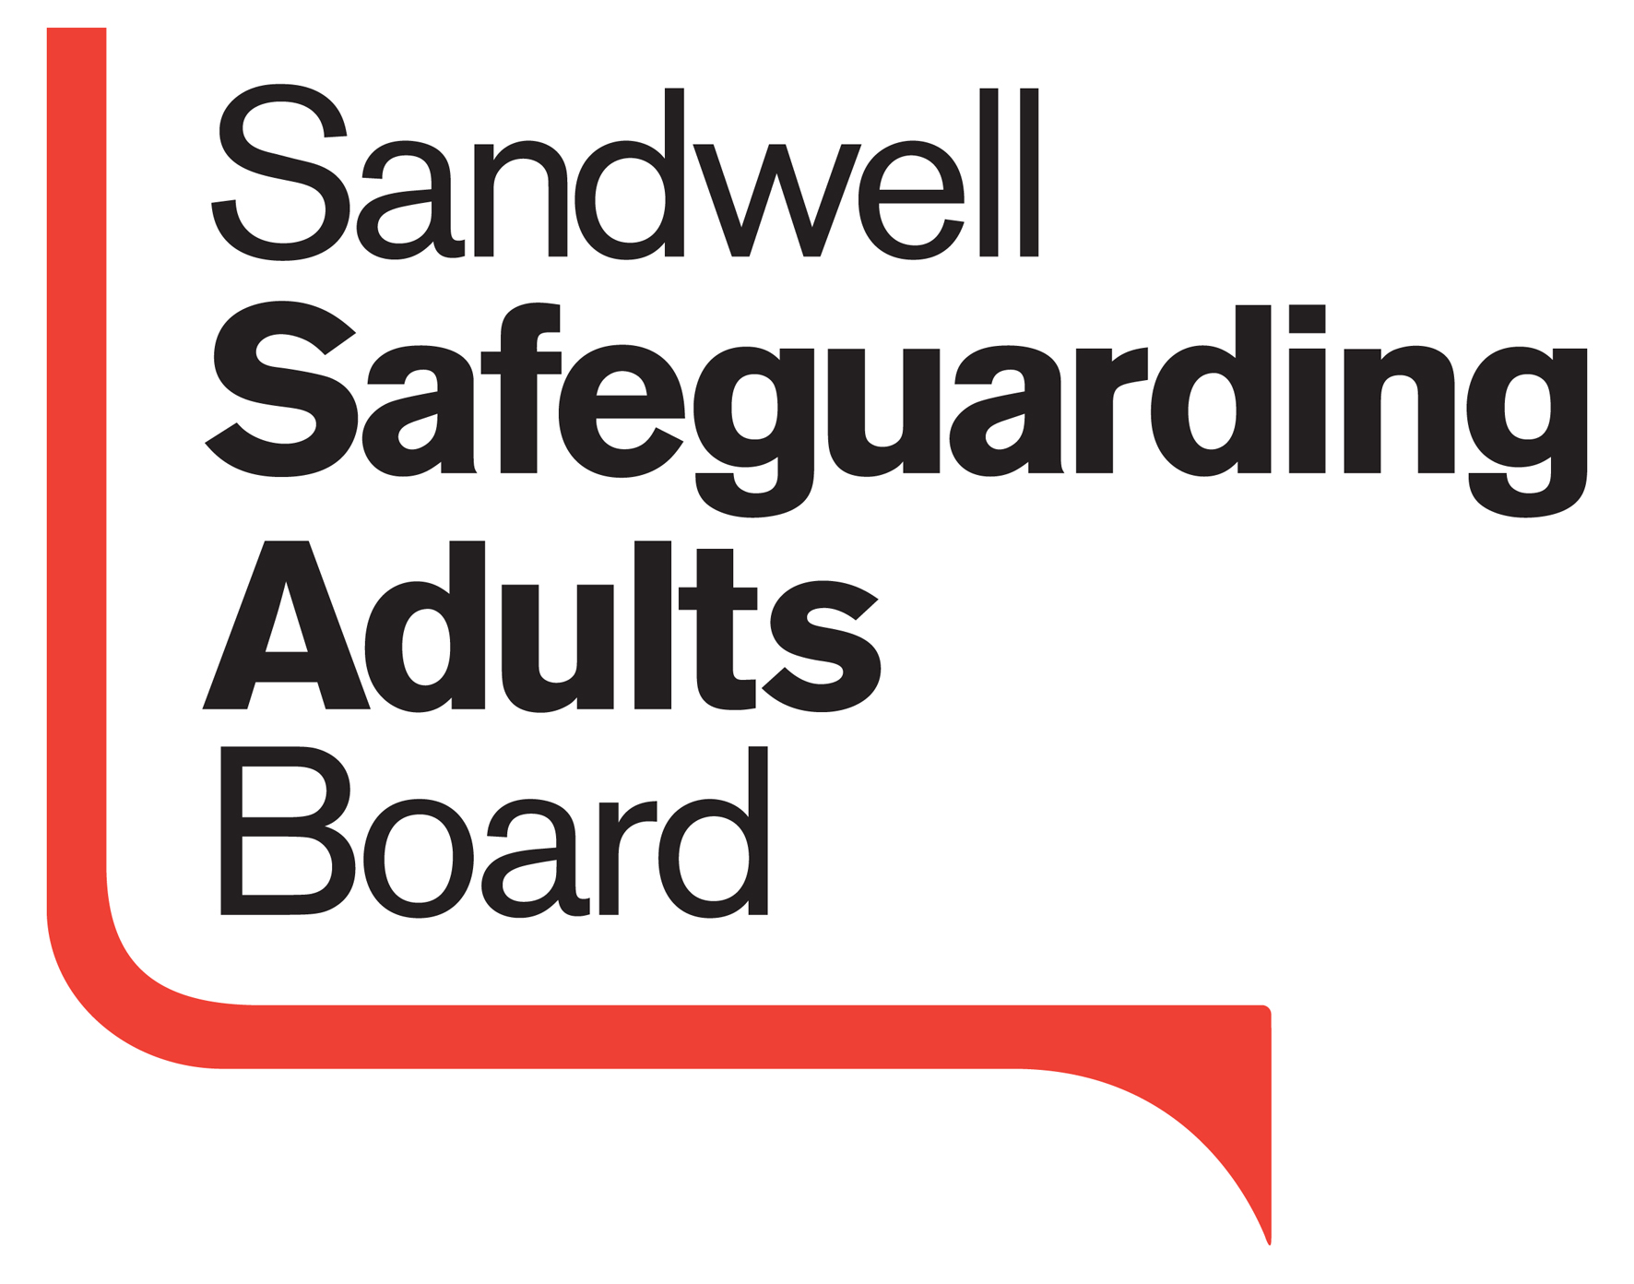**Sandwell Safeguarding Adults Board**

[](https://www.google.co.uk/url?q=http://www.kumb.com/forum/viewtopic.php?f=2&t=160542&p=4523296&sa=U&ved=0CBYQwW4wAGoVChMI453Ppf_QyAIVwlcUCh3cOwoA&usg=AFQjCNE1-5OGPsGp-hNnAINhk5CzXAahug) **SSAB@SSAdultsBoard**

[](https://www.google.co.uk/url?q=http://www.kumb.com/forum/viewtopic.php?f=2&t=160542&p=4523296&sa=U&ved=0CBYQwW4wAGoVChMI453Ppf_QyAIVwlcUCh3cOwoA&usg=AFQjCNE1-5OGPsGp-hNnAINhk5CzXAahug)**SSAB@SSAdultsBoard**



**Easy Read Strategic Plan**

**2015-2018**

**Prevention, Learning & Development Sub Group**

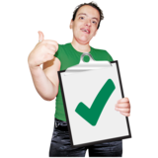

**What We Will Do**

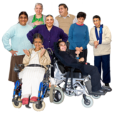

We will hold campaigns, activities and conferences during 2017 with all of our partners and work together to offer the right kind of help and support at the right time to people who may need it or think they need it to help them change the things they want to.



We will write a new training plan make sure that everybody has access to current training and learning opportunities about Safeguarding.

**Safeguarding**

**Quality and Excellence Sub Group**



**What We Will Do**

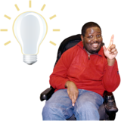

We will ask other people to tell us what we do well and what we could do better.

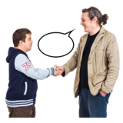

We will tell our partners what we know about people’s lives who live in Sandwell and have support needs.

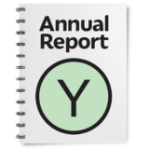

We will produce an Annual Report.



This work will be done during the summer of 2017.

**Protection Sub Group**

**What We Will Do**

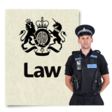

We will make sure that everyone is doing what the Law says they are meant to be doing and we will continue to work together to keep people with support needs safe in Sandwell.

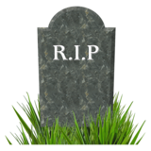

If somebody dies or is injured we have to learn from this and share our learning to try and prevent something similar happening again.



This work will be done during the summer of 2017.

